- Testing to Inform Evaluation
  - These are the overall post development tests that I carried out to inform my evaluation of my first prototype. I was testing for function and robustness of my first prototype and I have annotated the test results. The tests that I carried out were:
- Testing against overall requirements.
- Useability Testing each with stakeholders as follows:
  - Login GUI
  - Options GUI
  - Manage Account GUI
  - Admin Management GUI
  - Play Game GUI
  - Leaderboards GUI
- Functionality Tests against the specification

- Testing Against Overall Requirements.
  - I conducted Pass/Fail testing against the overall requirements for my project and the table below shows the results of these tests, annotated with my comments on each requirement area:
Requirements Set at Start of Project | My Comments | Test plan page | P/F
A. TYPES OF ACCOUNT  - There will be two different types of accounts with different privileges:  - User: This is the Default privilege. A User can have an Avatar for the hero and can only play the game and view leaderboards.  - Admin: Can View Leaderboards; Can Add/Delete mazes or quiz sets; can view student progress (e.g. accuracy or time taken); can possibly set time allowances; but an Admin cannot play the game unless logged in as a User.  - User will be anyone at school who wishes to play the game.  - Admin will be myself and/or the computer teacher because they will want to set questions and add mazes rather than play the game. They should have the option to add or update quiz sets as part of managing their accounts. | Admin
 | Admins are denoted using “A_” at the start of their username when logging in. | 231-234 | P
If an Admin logs in, all options are available:
If a User logs in, Admin options are greyed out.
If Admin Users try to play a game, they will get warnings that they cannot play the game and are only able to test if it loads correctly. (this is so they can test that a new maze/Clueset has been added correctly to the database)
 |  | 209 | P
 |  | 225 | P
 | In manage account, neither admin nor user can change their username. (Maintenance: In future, I would like the ability for Usernames to be changed in the Manage Account GUI but not be able to change the type of user. This will be in a future prototype due to time constraints at this point in the project.). Admin users can change their avatar(even though it is not used). | 245-248 | P
 | As an Admin, selecting the Admin Management option in options enables them to add new mazes and Clue sets and associate them. | 255-256 | P
 | When viewing a Leaderboard Admin users can view detailed descriptions of a specific users last game(of the chosen game). | 266 | P
 | User
 | The User can log in with any authorised username. | 174-175  186 | P
 | Their options are limited to Managing their account, Play games, view leaderboards. | 196-197 | P
 | When managing their account like admin users they cannot change their usernames but can change their avatar.(Used when playing games). | 252-253 | P
 | Users can select a game (can be sorted and selected by difficulty). | 220-221 | P
 | Users can view a top 5 leaderboard sorted by descending score, for a selected game. If two scores are the same there is automatic sorting by time taken and then Accuracy (it is unlikely these will be identical for more than 1 user) | 265-268 | P
B. LOG ON  - A new player must be able to create an account and choose a username that passes the validation requirements for a unique username in the database. I would like users to create their own account without the need for me to pre add it to the database.  - A new player must be able to create an Avatar (a small graphic image) to represent themselves as the hero and it must be possible to change the Avatar.  - A player must log on using a Unique Username rather than a PIN. This requirement comes directly from my peer survey.  - For validation purposes, the username must be between 0 and 12 characters long and must not contain white space. injection attack which uses ‘(‘ and ‘;’.  - The username entered must match an existing username in the database so that it can be authenticated.  - A new player must be able to create a Username. It must be a mix of upper case and lower case and digital characters, and it can have ‘-’ or ‘_’ as special characters in order to protect against SQL.  - A maximum of 5 log on attempts will be allowed to prevent brute force attacks that would eventually find an authentic username.  - The ability to manage their accounts must be available to players who are logged in, so that they can change their username (limited to once a week because all records will need to be updated) or delete their account and all associated records.  - A Login Record could have the fields: UserID, Username, Avatar, Permissions (where Permission is ‘user’ or ‘admin’). I may want to add Admin Users myself. | The Log On GUI gives a new user the option creating a new account (so I don’t have to create one for them). | 174-175  194 | P
 | In the Create account they can create a username and select an avatar. | 229-231  252-253 | P
 | The Username is validated and authenticated to ensure it is not already in use. | 247 | P
 | But if authentication finds the username already in use the new use it prompted if they would like to edit an existing account. | 229  248 | P
 | If no then the details won’t save (it appears as though nothing happened) | 229  248 | P
 | Future Development Idea: Current accounts only editable from the Options GUI.
 | A User does log in with a unique username – authentication is used. | 186 | P
 | All usernames are authenticated against the User table. | 186 | P
 | Validation checks for:  - 1-12 chars in the username  - Characters are not forbidden (limited to: “a-z”, “A-Z”, “0-9”, “_”)  (This should protect against SQL injection but this aspect has not been tested) | 184 | P
 | - An Admin Logs in with “A_” at the start of their username. | 231-234 | P
 | Once logged on an authenticated User/Admin can see all these options: | 196-197 | P
C. HOME PAGE OPTIONS  When a user has been authenticated, they will be presented with the following options and only one option can be selected in order to transition effectively to the next level.  - Play a Game (User Only)  - Manage Account  - View Leaderboards (Admin Only)  - Quit the program or Sign Out  - Add a Quiz or Maze (Admin Teacher only) | - Play a Game  Admin users can also select this GUI but will get an information pop up warning them they cannot play games but can test if it loads  Users can go straight to the play game GUI | 196 | P
 | - Manage Account  Both can go to the manage account GUI  A warning will pop up warning about logging out | 196 | P
 | - View Leaderboards  Both can go to the view leaderboards GUI | 197 | P
 | - Quit the program or Sign Out  Both can select to quit and return to the log on GUI | 196  175 | P
 | Add a Quiz or Maze (Admin Teacher only)  Now called Admin Management. (greyed out for users) only admin can access it. | 197 | P
 | Users and Admin users can both access the manage account GUI. | 229-231 | P
D. MANAGE ACCOUNT  - The “Manage Account” menu for users will include the following options to modify an existing account:  - Change Username (with same validations as creating a username)  - Change Avatar;  - Delete the Account  - The “Manage Account” option for Admins will include the following options to modify an existing account:  - Set or Adjust Quiz sets  - Set or Adjust Mazes  - Set or Adjust timers  - Modify leaderboard settings | They can both change their avatar (not used by Admins) | 252-253 | P
 | Both cannot change their usernames. | 229-231 | P
 | Accounts cannot currently be deleted because referential integrity would need to be applied (cascade delete) and Admin would not be able to view performance of deleted users.
 | Limitation: To maintain data protection according to the Data Protection Act of 1998, which I have studied since starting on this project, I will need to add with a sense of urgency a Delete option for my users, so they can delete their accounts. Without this, the game does not comply with the regulation as it stores data indefinitely and it means that I cannot approach my Network Manager stakeholder at this point for her to even consider loading it onto the school network.
 | This was not added as part of admin manage account but instead as a separate Admin Management in options (separate from users)
- The “Manage Account” option for Admins will include the following options to modify an existing account:  - Set or Adjust Quiz sets  - Set or Adjust Mazes  - Set or Adjust timers  - Modify leaderboard settings | In Admin management Admin users can:
 | Create a game nickname | 255-256 | P
 | - Add a maze file name for that nickname | 255-256 | P
 | - Add a Clueset filename (That can be already in the database) for that game nickname | 255-256 | P
 | - Add a specified max time and difficulty for the new maze. | 255-256 | P
 | - They can select an existing game by nickname and change all the other inputs(associated clueset, associated maze, maxtime, difficulty. (a verification message is displayed before updating the database) | 255-256 | P
 | - Admin users can select a game and check if it loads correctly from the database. | 213 | P
E. PLAYING THE GAME  - Only Users can play the game and they should have the option to:  - Select a difficulty Level (Easy, Medium, Hard)  - Choose the clue set  - Choose whether to have a timer shown  - Choose whether to be added to a Leaderboard  - The game should be played with the chosen Avatar for the hero. | Messages are displayed confirming correct operation. | 212-214 | P
 | Users can select from a list of all available games no matter their difficulty. | 119  221 | P
 | The User can filter these by difficulty and select from those shown. | 221 | P
 | Maintenance (achieved within first prototype)-The user should be able to reset the filter so that all mazes are shown again (at present they have to return to options and return to play game GUI.) This is likely to annoy the users. Comment – I have since developed this functionality and so this test has been passed. | 221 | P
 | The user cannot select cluesets as they have been assigned to that game by Admins. | 224 | P
 | Timers are always in use – The user has no option.(All users playing that game have the same time allowance – fair) | 212-214 | P
 | All game performances are made available for leaderboards the user has no option. | 226 | P
 | If the user is below the top 5 only the admin will see a not so good performance. | 265 | P
 | The game plays with the avatar associated with the user. | 154 | P
 | Each game records in the User_Maze table: | 226 | P
F. RECORDED STATISTICS  - Points scored should be recorded.  - Time Taken should be recorded.  - Accuracy Level should be recorded (this is the number of correct clues per difficulty level).  - Number of questions answered correctly should be recorded (slower players may have a higher accuracy level). | - Total score at end of game | 129-130  226-227 | P
 | - Time taken (either max time if game ended due to time out or time that has elapsed before game over(clue positions is null or lives = 0)) | 147-149  226-227 | P
 | - Number of each level clues solved | 226-227 | P
 | - Accuracy  Number of each level solved/Total Number of each level answered  Weight * the level fraction  All levels added together  - Times by 100 with no remainders | 213  131-137 | P
 | Game Completed? Because Lives remaining not recorded. | 129-130 | P
 | - UserID (FK) | 226-227 | P
 | - MazeID (FK) | 226-227 | P
G. LEADERBOARDS  The Admin should be able to specify the Usernames to be included in the leaderboard and have the ability to hide specific users (e.g. test user account created by the admins). The admins should be able to view the results for a single maze by:  - Score  - Time Taken  The User should be able to view the Leaderboards set by:  - The Difficulty Level  - The Score  - The Time Taken | Users
 | The User selects a single game of all the games in the database including unplayed games(ordered alphabetically by nickname) | 265 | P
 | The User Leaderboard GUI contains the top 5 completed games for the chosen game. (ignores not completed games) | 265 | P
 | The Leaderboard is ranked primarily by decreasing score, if two scores are the same they are ranked secondarily by time taken and then by accuracy. | 268 | P
 | The User Leaderboard shows the Username, Score, Time taken and Accuracy for each record. | 265 | P
 | Admin
 | The Admin user selects a single game of all the games in the database.(ordered alphabetically by nickname) | 265 | P
 | The Admin Leaderboard GUI contains a Drop down of all the user which have played that game sorted alphabetically by completed(not completed are listed below completed)  Secondarily sorted by score. | 266  298 | P
 | Secondarily sorted by score.  An admin user can select a user to view the stats for that game and user in a pop up message. (Showing ***) | 268  266 | P

B. Functionality Tests
38.3.
- Does validation of data entry work? (especially database entry)
Log In GUI – (174-175), (184)
Manage Account GUI – (229-232), (247)
Admin Management – (225-256)

- Does a Leaderboard with less than 5 scores to rank work?
Leaderboards GUI – (265-266)

- Does the hero move to a random empty cell when captured by a spy? (gameplay)
Play Game – (119-120)

- Is an incorrect or null answer to a clue managed? (robustness)
Play Game – (123), (129-130)

- Does the end of the game return all the stats needed? (gameplay)
Play Game – (226-227)

- Are the game stats added to the database correctly for the leaderboard processing?
Leaderboards GUI – (265 – 268)

- Can a new account be created? (validation)
Manage Account GUI – (229-232), (247)

- Does an empty file (maze or clue) crash the program? (robustness)
Play Game GUI – (212-214), (224)

- Are there at least as many questions as there are clues in the game? (robustness)
Play Game GUI – (212-214), (224)

- Evaluation of Useability Features
  - I am moving on to record the useability testing of my first prototype, taking each key feature in turn and recording feedback from my Sixth Form stakeholders, my former computing teacher stakeholder, and the cyber security professional stakeholder. The features that I will test are the:
- Log In Screen
- New Account Creation / Manage Accounts (same screen)
- Options Selection
- Play Game Selection
- Game
- Leaderboards
- Admin Management

  - Development Testing
All of the features that I will be testing with stakeholders have already undergone a robust process during development to test the functionality for each part of the protype and fix errors when they appeared. I retested any errors that I fixed until applications worked as expected. This development testing is recorded in detail within Iterations 2 and 3 of this document, with screenshots of the White Box Testing included in those sections.

  - Useability Testing
    - Log In Screen Evaluation
This is the first screen that users see when they want to play the game and they have the choice of either logging in as an existing user or creating a new account:
Colours and simple lay out were liked
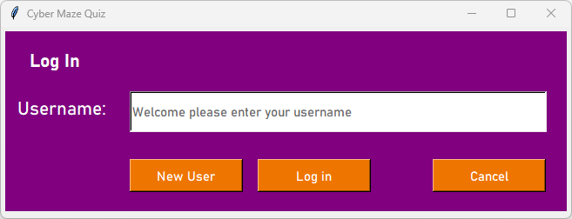
Friendly instruction as temporary text
Function Title of this screen is clear
A future development could be to add “or click New User” to the temporary text
A future development could be to get rid of this Log in button and use the Enter Key instead
Clear place to go for new users

Usability Testing with Stakeholders
Sixth Form stakeholders liked the friendly feel of the Log In screen and said it had a nice colour scheme with a really clear font and a good layout. They said it was easy to navigate, and they were able to navigate the Log in process to create new accounts and felt happy and welcomed. It functioned correctly as a log in procedure and my stakeholders were able to use it. They found the button for a “New User” was easy to see and click if you didn’t have an account already.
Computer teacher stakeholder: he had moved schools, but I kept him as my stakeholder for this project to maintain consistency. He also liked the Log In screen, confirming that it is welcoming, easy to navigate and easy to use.
Cyber professional stakeholder: they said that the Log In screen met their brief well because it was eye catching, with clean lines, not over fussy and it will appeal to students. They really liked the retro colour scheme.

Improvement Suggestion
The Sixth Form stakeholders had two improvement suggestions for the Log In screen and said both were “nice to have” not essential. Ideally, they would like to use the keyboard enter key to submit the input, rather than having to click on a separate enter button, and they suggested adding “or click New User” to the temporary text.
Evaluation Conclusion for Log In Screen
As a result of the positive stakeholder feedback, which was building on the successful development testing, and the minor improvements suggested as optional, I am rating the Log In feature as: Successful

    - New User Account Creation / Manage Accounts Screen Evaluation
This is the screen that a user is sent to when they click the “New User” button on the Log in screen (or Manage Account on the Options screen). It allows them to choose their own username and choose an avatar for their new account. This screen is also used for managing accounts, if for example, a pre-existing user wants to change their avatar.
Easy to navigate back to the Log In Screen
Friendly instruction as temporary text
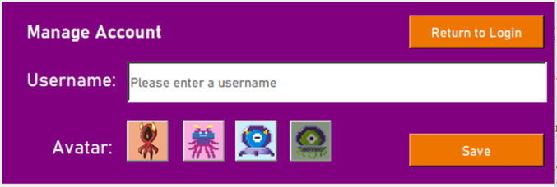
Function Title of this screen. Might be worth saying “Create or Manage Account”
Easy to understand button to save account details
A future development could be to create a pop up box that provides the rules for eligible Usernames
Option to choose avatar was really well liked

Usability Testing with Stakeholders
Sixth Form stakeholders liked the friendly feel of the New Account Creation/Manage Account screen and liked the continuation of the colour scheme from the Log In screen. They found the layout easy to understand and most of all, they loved the ability to choose their own username and pick an avatar – this was really important to them so they were very happy to see it included. They said it was easy to navigate, and they were able to create new accounts. It functioned correctly as a procedure to create a new account or manage an account and my stakeholders were able to use it.
Computer teacher stakeholder: he liked the Manage Account screen and was really pleased that I had been able to give the option of choosing an avatar and choosing your own username. He felt this was really important for encouraging students to engage with the game.
Cyber professional stakeholder: they loved the avatar options and said that this screen was clear and easy to use.
Improvement Suggestion
My Sixth Form stakeholders were able to create usernames and choose an avatar, but the Computer Teacher stakeholder said that it would be useful in the future to have information pop ups to guide users about what an eligible user name needed to have by way of number of characters/digits/special characters etc (this could avoid a new user getting frustrated if their chosen username was ineligible). It might also be worth showing the screen title as “Create or Manage Account” rather than just “Manage Account”.
Evaluation Conclusion for New Account Creation / Manage Accounts
As a result of the positive stakeholder feedback, which was building on the successful development testing, and the improvements suggested as a future consideration, I am rating the Manage Account feature as: Successful

    - Options Selection Screen Evaluation
This is the screen that a user is sent to when they have just logged in via the Log In screen. It gives them a menu of options so they can choose what to do next. They can choose to manage their account (reviewed above), they can play the game, they can view leaderboards, or they can go back to the Log In screen. For normal users, the option called “Admin Management” is greyed out. This is also the Options screen that an Admin will see, although for the Admin, the option to “Play Game” would be greyed out.
Easy to navigate to the Manage Account Screen
Easy to navigate back to the Log In Screen
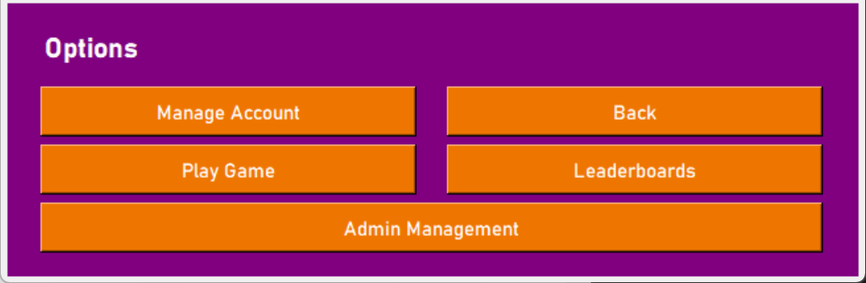
Play Game button is greyed out for Admins
Function Title of this screen is clear
Admin Button is Greyed Out for Normal Users
A future development could be to make the “Play Game” button more dominant on the page
Easy to view Leaderboards

Usability Testing with Stakeholders
Sixth Form stakeholders liked the really clear format of the Options screen and said it was easy to navigate and they could understand how to use it easily. It continues the colour scheme from the other screens, so it feels coordinated and flows nicely.
Computer teacher stakeholder: he liked the Options screen and said that it was really clear what to do and people would find it easy to use. He was please with its functionality.
Cyber professional stakeholder: again, they said it met their brief of being easy to use with the same attractive retro colour scheme to tie it in with the previous screens.

Improvement Suggestion
My Sixth Form stakeholders suggested that a future improvement would be to make the “Play Game” button more prominent, so that it is the biggest button on the Options screen. They think that play game will be their “go to” option, so having it large on screen will make it easier for them.
Evaluation Conclusion for Options Screen
As a result of the positive stakeholder feedback, which was building on the successful development testing, and the improvement suggested for the future, I am rating the Options screen as: Successful

    - Play Game Screen Evaluation
This is the screen that a user is sent to when they have just clicked Play Game from the Options screen. It gives them two drop down menus: one is to select the display name of the game that they want to play; and the other is to select the difficulty level of the game they want to play, choosing from Easy, Medium and Hard. There is a Back button in case they want to go back to the Options menu and there is a Submit button to lock in their game choices and move on to playing a game.
Easy to navigate game choice drop down
Easy to navigate back to the Log In Screen
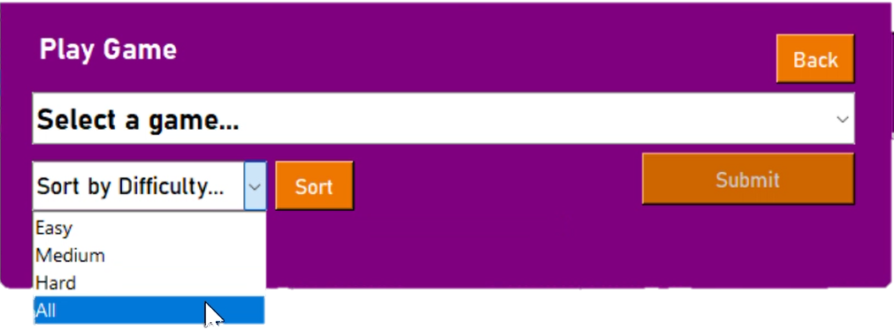
Easy to navigate difficulty level choice
A future development could be to rename “Sort by difficulty” and call it “How difficult should your Game be?”
A future development could be to rename “Sort” and call it “Confirm Difficulty Level”
Function Title of this screen is clear
Easy to view Submit button to lock in game choices

Usability Testing with Stakeholders
Sixth Form stakeholders liked the drop down choices, finding them really clear and easy to navigate. They like the colour scheme that follows through from the other screens, so it feels coordinated and flows nicely.
Computer teacher stakeholder: he liked the functionality of the Play Game screen and said that users would find it really easy to navigate and is exactly what he was hoping to see.
Cyber professional stakeholder: they loved the drop-down difficulty level choices because it gives the user control over the game they play and having difficulty levels meets a big requirement for the cyber professional, which is to make sure the game is pitched at the right level for the users.
Improvement Suggestion
The cyber professional suggested that a future improvement would be to make the language on the difficulty level selection a bit softer and more welcoming. They suggested wording something like “How difficult should your Game be?” rather than “Sort by Difficulty” and they thought the selection button for this menu could be called “Confirm Difficulty Level” rather than “Sort” because this would mean more to the user.
Evaluation Conclusion for Play Game Screen
As a result of the positive stakeholder feedback, which was building on the successful development testing, and the improvement suggested for the future, I am rating the Play Game Screen as: Successful

    - Game Evaluation
This is the game that users play. The hero is shown by the user’s avatar and the aim is to avoid the spies because any contact with the spies will lose a life (the number of lives left is shown in the stats banner at the bottom of the screen). The spies can move dynamically around the maze whereas the hero can only move with the arrow keys to adjacent free squares. If the hero meets a spy and loses a life, the hero will be repositioned to a random empty square for its next life. The hero can answer questions and score points by going to the clue squares. The hero has 3 lives and when they are lost, the game is over. Otherwise, the game lasts for the length of time set by the admin or until all of the clue squares have been used up. The score from answering the clues adds up in the stats banner at the bottom of the screen to give a score for the game.
The name of the chosen game
User’s Avatar
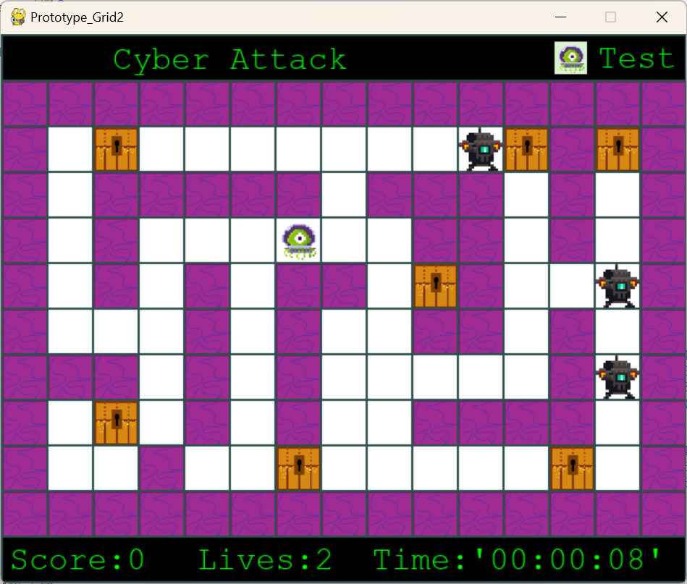
Path around grid is white squares
Walls are purple squares
The Spies who will kill the hero
Clue Squares
Username

Hero (user’s avatar)
Stats banner for this game, giving score, lives left and time taken

Pausing the Game
If the player would like a break, they can hit any key (apart from the arrow keys) to pause the game. This is the screen that appears, and it gives them the option to restart the game, resume the game or quit the game.
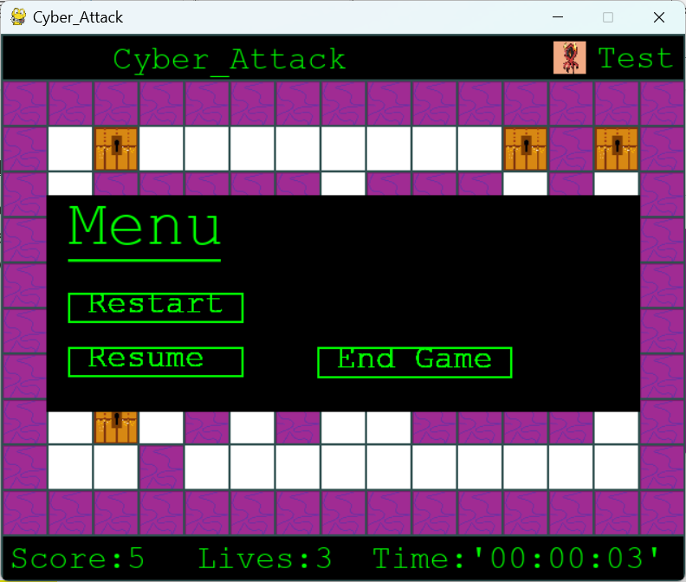
Clue Questions
When the hero reaches a clue square, this is how the question appears, and the countdown for the individual question timer starts so that the user knows how long they have to input the question. When they type the answer, the text appears on screen below the question:
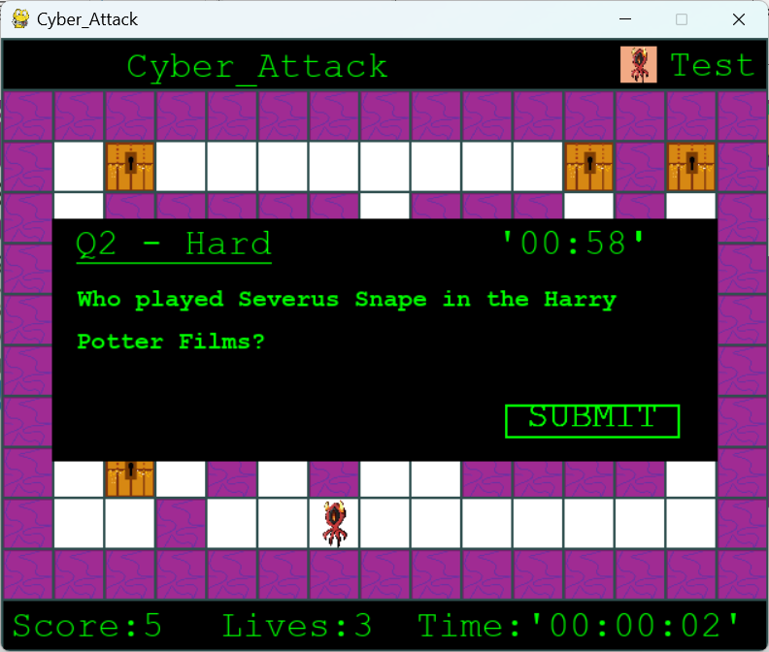
Game Over
The following stats panel will display when game over happens either due to 3 lives being lost, all clue squares on the screen have been answered or because the game has finished after the amount of time set for that game by the Admin:
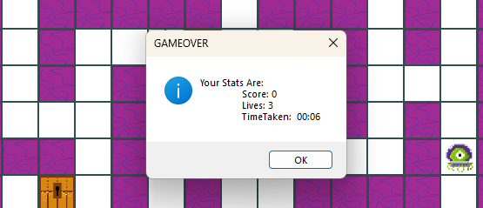

Usability Testing with Stakeholders
Sixth Form stakeholders really liked the game. They said it was quick to play, which was a really good thing and they loved the spies, which they said looked like real baddies with feedback like “cool monster” and “the spies are fun”. Navigating around the maze was fun and it was good trying to escape from the spies. They thought the clues worked well and they were happy with the stats banner at the bottom of the screen. They thought the difficulty level to play was about right and one of them said “I succeeded in the game after three tries, so I liked winning!”. They all liked the retro Pacman feel of the game with the simple concept of avoiding the spies and getting to the clue squares. They liked the definite Game Over pop up that provided them with the stats for the game they had just played.
Computer teacher stakeholder: he liked the quickness of the game and the fun graphics. He thought it would be a great game to develop into something for his classes to use. He liked the pause function of the game, so that if players needed a quick break to think about their next move, they could take a pause. He said it was exactly what he was hoping to see.
Cyber professional stakeholder: they loved the game and said it met the brief of creating a simple fun game that would encourage people to engage with cyber. In this prototype, I have used my test clues, but now the concept is tested, I have a cyber clue set ready to add to the game, which I showed to the cyber professional and they thought the cyber questions hit the right level.
Improvement Suggestion
The stakeholders recommended that a small set of game play instructions might be useful for people who don’t like learning as they go. They also said that having a flashing curser underneath the clue questions would be a clearer indication that they could just type the answer in straight away. One of my stakeholders is colour blind and said that the avatar they chose was hard to see (the light blue avatar), so a future iteration will need research and some avatar options that offer better colour differentiation for colour blind players. Another of my stakeholders is left handed and they asked for left handed arrow keys (ASWD) to be offered in a future version of the game.
Evaluation Conclusion for the Game
As a result of the positive stakeholder feedback, which was building on the successful development testing, and the improvements suggested for the future, I am rating the Game as: Successful

    - Leaderboards Evaluation
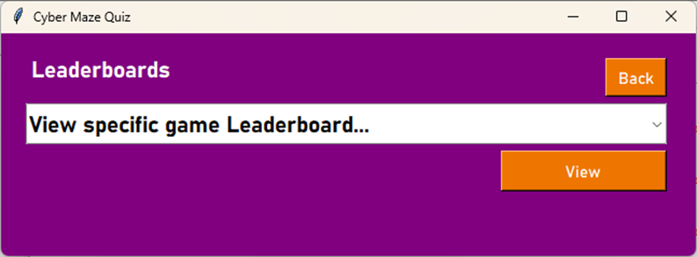
This is the screen that any account type is sent to when they have just clicked the Leaderboards button on the Options screen. The dropdown menu on the screen gives the display names of all of the playable games and the user can select the game for which they want to view the leaderboard:
Easy to navigate to the previous screen
Easy to see View button to select a specific Game Leaderboard to view their stats
Function Title of this screen is clear
Colour scheme follows previous screens
Easy to navigate with a drop down list of all Games available
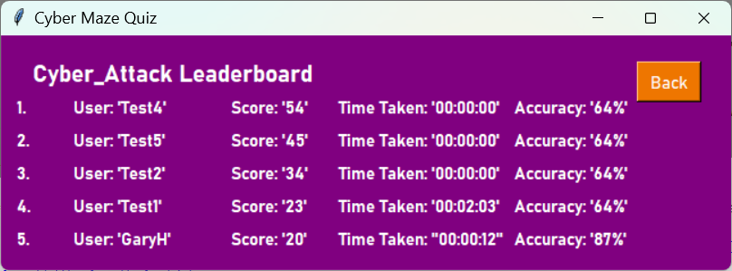
Having selected a Leaderboard of a specific game, the next screen shows what the regular user will see next (the Admin sees a different view). The Leaderboard shows the top five top scoring players for that game, displayed in rank order:
Easy to navigate to the previous screen
A future development could be to include avatars on the leaderboards
Title of this screen is clear
Colour scheme follows previous screens
List of top 5 players for the game called CyberAttack

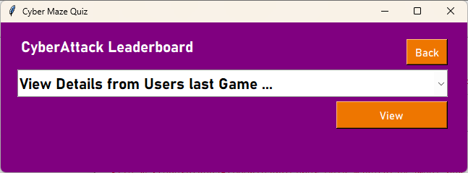
This is the Leaderboard for the Admin, where the drop down menu shows usernames that are sorted by the score achieved in the game (highest first) rather than by alphabetical order:
Easy to navigate to the previous screen
Easy to see View button to select a specific user to view their stats
Title of this screen is clear
Colour scheme follows previous screens
Easy to navigate with a drop down list of users that have played this game (the game being reviewed here is called “CyberAttack”.

Usability Testing with Stakeholders
Sixth Form stakeholders liked the leaderboards, finding them really clear and easy to navigate. They like the colour scheme that follows through from the other screens, so it feels coordinated and flows nicely. One of them was really excited to see themselves as the highest score on the leaderboard!
Computer teacher stakeholder: he liked the functionality of the Leaderboards and felt that he could make use of them with his class. He tested the Admin Leaderboard and found that it worked well.
Cyber professional stakeholder: they loved the Leaderboard option because it could motivate users to keep going with the game and try to climb the leaderboard.
Improvement Suggestion
The Sixth Form stakeholders thought that including the avatars on the leaderboard would be a good idea for the future because it carries the personalisation of the avatar throughout the game.
Evaluation Conclusion for Leaderboards
As a result of the positive stakeholder feedback, which was building on the successful development testing, and the improvement suggested for the future, I am rating the Leaderboards as: Successful

    - Admin Management Evaluation
This is the screen that an Admin is sent to when they have just clicked the Admin Management button from the Options screen. It gives them the option to type a Display Name (the title of the Game) that they wish to work on. They can then enter a Maze filename and link a Clue Set filename to this. The other areas that an Admin can choose to change are the maximum time allowed for a game and the difficulty level. By having these as drop-downs, it limits the scope for error and gives specific entry values, which I can more easily manipulate. Once the changes have been entered, the Admin clicks “Save” and if a game with the same Display Name exists, it will pop up with a warning message asking if the Admin is sure they want to edit the game.
Easy to navigate to the previous Screen
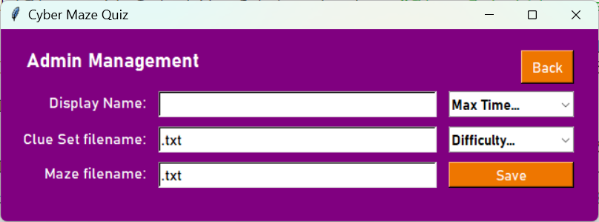
Drop down menus to reduce errors
Function Title of this screen is clear
A future development could be to add some friendly temporary text
Enter a Maze filename and link a Clue Set
Enter Display Name for a game

Save button to confirm input

Usability Testing with Stakeholders
Computer teacher stakeholder: he liked the functionality of the Admin Management screen and said that it would give him the admin options that he would need to maintain the game..
Improvement Suggestion
The computer teacher stakeholder suggested that a future improvement could be to add some friendly temporary text into the input boxes
Evaluation Conclusion for Play Game Screen
As a result of the positive stakeholder feedback, which was building on the successful development testing, and the improvement suggested for the future, I am rating the Admin Management Screen as: Successful
Maintenance and Limitations of Solution

  - I am really pleased to have created a working game that has received positive feedback from my stakeholders. I have achieved a maze game with retro graphics and a fun feel that has a hero, spies and clues within a maze layout. It is a robust game because it is underpinned by a reliable database and GUIs which were created through decomposition and an iterative development process and tested thoroughly.

  - I will now look at “Maintenance”, which are the things I would modify and update in the software to develop the next version of this first prototype. After, evaluating the Maintenance Requirements, I will look at the “Limitations” of the solution, which are the inherent constraints or disadvantages of my solution.

Maintenance Points and Planned Improvements
  - I am happy with the development of my first prototype and throughout the project testing and stakeholder engagement, I have noted points to work on before releasing a final prototype of my game as follows:
- Log In GUI: I have put in validation requirements to prevent SQL injection opportunities and will need to fully test this before my final prototype. I will pursue the suggestions from the useability testing, which were to consider using the keyboard enter key to submit the input, rather than having to click on a separate enter button, which will require some research but should be achievable with some changes to the way the enter character is handled. I will change the temporary text in the Log In input box to something like “Welcome, Please Enter your Username or click New User”, which is a quick fix.
- Manage Account GUI: For my final prototype, I will change the text of the Manage Account GUI so that it changes depending on the previous GUI to “Create Account” or “Manage Account”, also if the title is Manage Account, the username could be pre-entered into the entry box, which are relatively quick fixes. I could add scroll over text to tell new users the validation requirements for usernames, and this can be achieved relatively easily with some research. I have put in validation requirements to prevent SQL injection opportunities and will need to fully test this before my final prototype. Finally, I would like to offer the ability for Usernames to be changed in the Manage Account GUI but not be able to change the type of user – to do this, I would have to identify the user id of the account before entering the Manage Account GUI from Options.
- Options GUI: I would like to pursue the suggestion that came from useability testing to make the “Play Game” button into a more dominant button on the screen and this is a quick fix, though I would have to look into the psychology of user behaviour to confirm the best location for the Play Game button (probably top left). To improve efficiency of the programme, I could try to move all frames in a single procedure, based on the sub program algorithm that I have already created, which is an easy fix.
- Play Game GUI: I will definitely respond to the useability testing to make the temporary text in the play game selection screen more friendly with a shortened version of “How difficult should your Game be?” rather than “Sort by Difficulty” and I will use words similar to “Confirm Difficulty Level” rather than “Sort” on the selection button. These are both easy fixes once I have chosen the right words.
- Game Play: For the game play itself, the requirement for left handed arrow keys is straightforward but I would need to research how to toggle between the different modes for left and right handed play. Avatars that work for colour blind users is something to resolve for the final prototype and is an easy fix by finding avatars that contrast in colour as much as possible to the game. I could look into adding a pre game pop up with game instructions, which would be fairly easy to incorporate and I could try to put a flashing curser beneath clue set question for text entry – this might be more difficult to achieve and would need targeted research. At the moment, the clue set only has my test questions, so my final prototype will need to have full clue sets with a cyber theme. I have questions ready to load for the final prototype, such as:
- What is Malware short for? Malicious Software
- What Software secretly monitors someone? Spyware
- What is Malware inside another file? Trojan
- What Protects Computer Systems from Cyber Criminals? Cyber Security
- What is accessing a computer system without permission called? Hacking
- What is accessing a computer system with the owner’s permission called? Ethical Hacking
- What is the malware that demands money to access your data? Ransomware
- What is malware that can multiply without using a file? Worm
- What is malware that needs a file to multiply? Virus
- Leaderboards GUI: I will aim to meet my stakeholder feedback to include avatars on the leaderboards for the final prototype and this should be fairly easy as I would only need to add an image to a label, which I have attempted before. I will also consider whether to show alternatives to the descending score on the leaderboards via alternative sorting. This would not be too difficult but I would have to adapt the style of my GUI to achieve this. For the Admin leaderboard, I would attempt to give them the option of selecting a date range to view player stats or something similar and this would require editing the fields in the database, which would make it more complicated.
- Admin Management: I will include some friendly temporary text into the input boxes for the final prototype, which is a quick fix. I have put in validation requirements to prevent SQL injection opportunities and will need to fully test this before my final prototype. I might also consider giving the option of editing the number of lives available to users for a particular maze, which could be saved within the maze database table with a new field. It would not be too difficult to adapt the maze play game functionality to suit this.
Limitation and How to Deal with it
  - I have one very significant limitation in the Manage Account GUI that must be resolved urgently. I am listing it under Limitations rather than Maintenance because it is a significant weakness, which will need to be addressed. A delete button should be added to allow a user to delete an account. This is important due to the Data Protection Act of 1998 which requires unnecessarily held personal data to be deleted. This limitation has meant that I have not sought feedback from the network manager stakeholder for this first prototype, because I know it is a significant issue that needs to be fixed before approaching the network manager about uploading anything on the school system. To combat this issue, I would need to adapt a cascade delete functionality within my database to eliminate orphaned records. This would mean that all game data for these users would be lost when they are deleted. I would need to talk to my teacher stakeholder to see if they wanted to keep this (anonymised) game data and attach it onto an unknown user record. If this is the case, the cascade delete would not be needed but I would need to link the UserID for the “unknown” record within the orphaned User_Maze record. This method may not be exactly right and I may need to do some further research on this before developing it for my final prototype.

